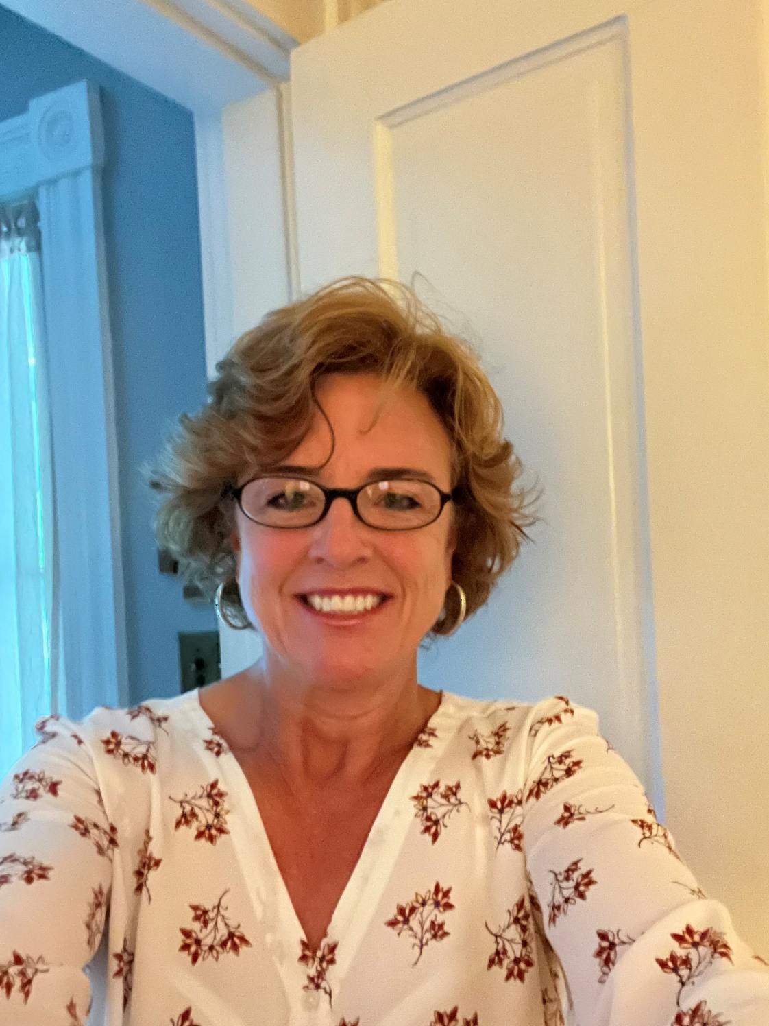
Deanne Marshall
As the newly appointed chairwoman of the Orange County Republican Committee, Deanne Marshall brings a wealth of experience, leadership, and dedication to the role. With a background in community service and outreach, Deanne has consistently demonstrated a strong commitment to the betterment of Orange County.
Driven by a passion for democracy, Deanne is committed to advancing electoral success through voter engagement, candidate support, and fostering relationships with precinct volunteers, poll workers, and poll watchers.
Prior to joining the Orange County Republican Committee, Deanne held a variety of roles in the Orange County Chamber of Commerce, including President and Executive Director.
Outside of her role as Chairwoman, Deanne is actively involved in the Orange County community. She currently serves as Vice Chair of the Orange County Health Commission, Treasurer/Secretary of the Orange County Education Foundation, and Vice President of the Orange Rotary Club. Deanne is a member of the Orange County Social Services Advisory Board, the Orange Downtown Alliance, and volunteers weekly at the Love Outreach Foodbank.
Deanne is a wife, mother of three, and dairy farmer.

